NAME: NITHISH KUMAR V R

ID: vrsathish15@gmail.com

Coding Challenges 1.1

1. **Write a program to find largest of three numbers.**

**PROGRAM:**

import java.util.Scanner;

public class largest number {

public static void main(String[] args) {

Scanner scanner = new Scanner(System. in);

System.out.println("Enter first number : ");

int a = scanner.nextInt();

System.out.println("Enter second number : ");

int b = scanner.nextInt();

System.out.println("Enter third number : ");

int c = scanner.nextInt();

if (a > b && a > c) {

System.out.println(a + " is the largest");

} else if (b > a && b > c) {

System.out.println(b + " is the largest");

} else {

System.out.println(c + " is the largest");

}

}

}

**OUTPUT:**

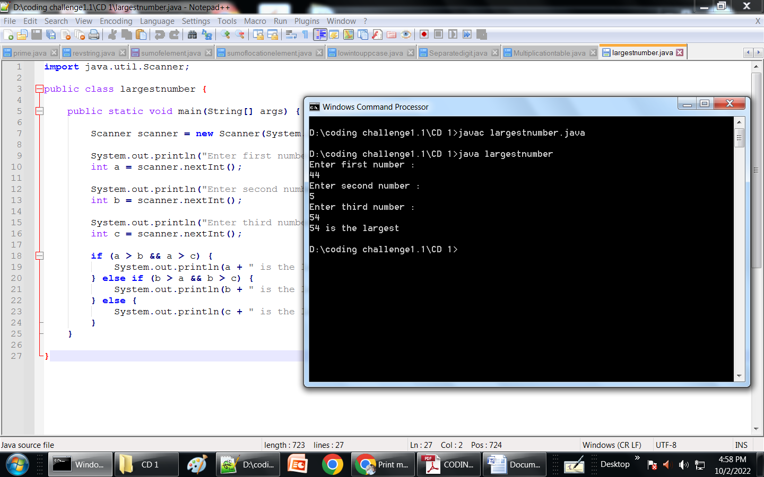

1. **Write a program to swap two variables.**

**PROGRAM:**

import java.util.*;

public class swaptwovariables {

public static void main(String[] args){

Scanner sc =new Scanner(System.in);

System.out.print("enter the a=");

int a=sc.nextInt();

System.out.println("enter the b=");

int b=sc.nextInt();

int temp = a;

a = b;

b = temp;

System.out.println("After swap");

System.out.println("a = " + a);

System.out.println("b = " + b);

}

}

**OUTPUT:**

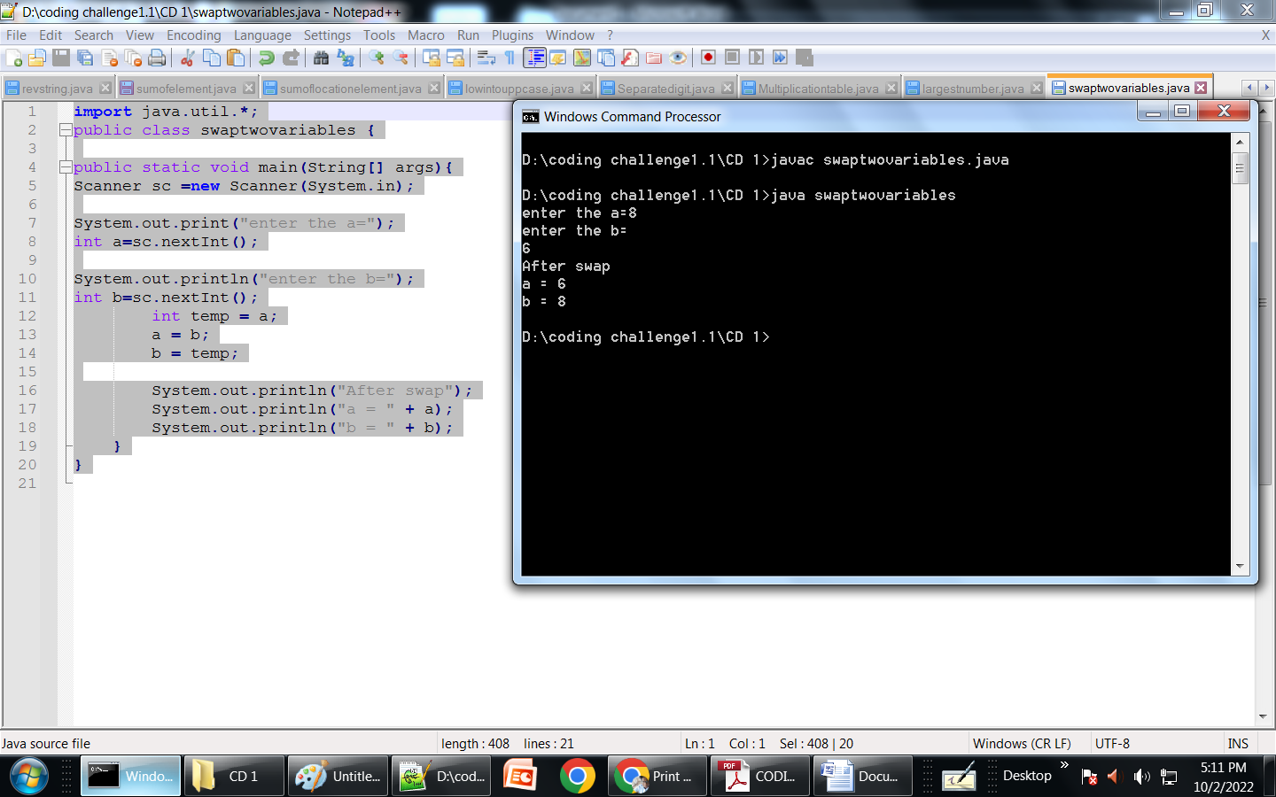

1. **Write a Java program to print the area and perimeter of a circle for the radius value 7.5.**

**PROGRAM:**

public class AP_of_circle{

private static final double radius = 7.8;

public static void main(String[] args) {

double perimeter = 2 * Math.PI * radius;

double area = Math.PI * radius * radius;

System.out.println("Perimeter of circle = " + perimeter);

System.out.println("Area of circle = " + area);

}

}

OUTPUT:

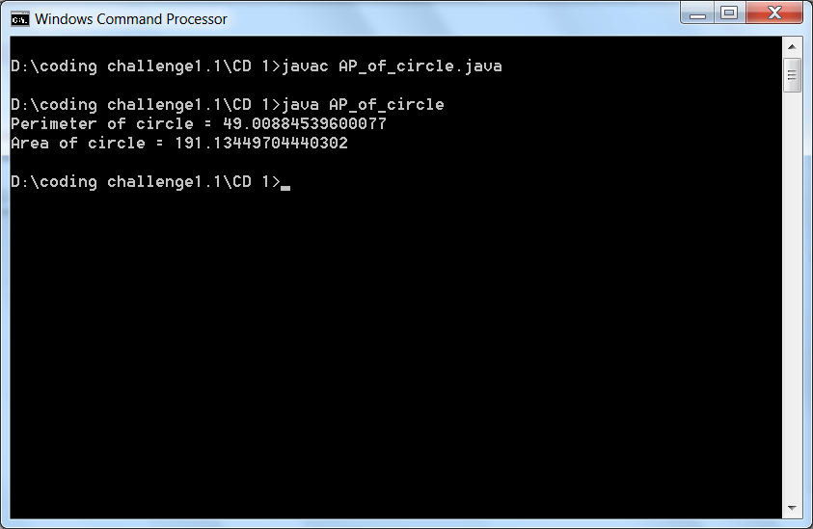

1. **Write a Java program that takes three numbers as input to calculate and print the average of the numbers.**

**PROGRAM:**

import java.util.Scanner;

public class Averageofnumber {

public static void main(String[] args) {

Scanner in = new Scanner(System.in);

System.out.print("Input first number: ");

int num1 = in.nextInt();

System.out.print("Input second number: ");

int num2 = in.nextInt();

System.out.print("Input third number: ");

int num3 = in.nextInt();

System.out.println("Average of five numbers is: " +

(num1 + num2 + num3 ) / 3);

}

}

**OUTPUT:**

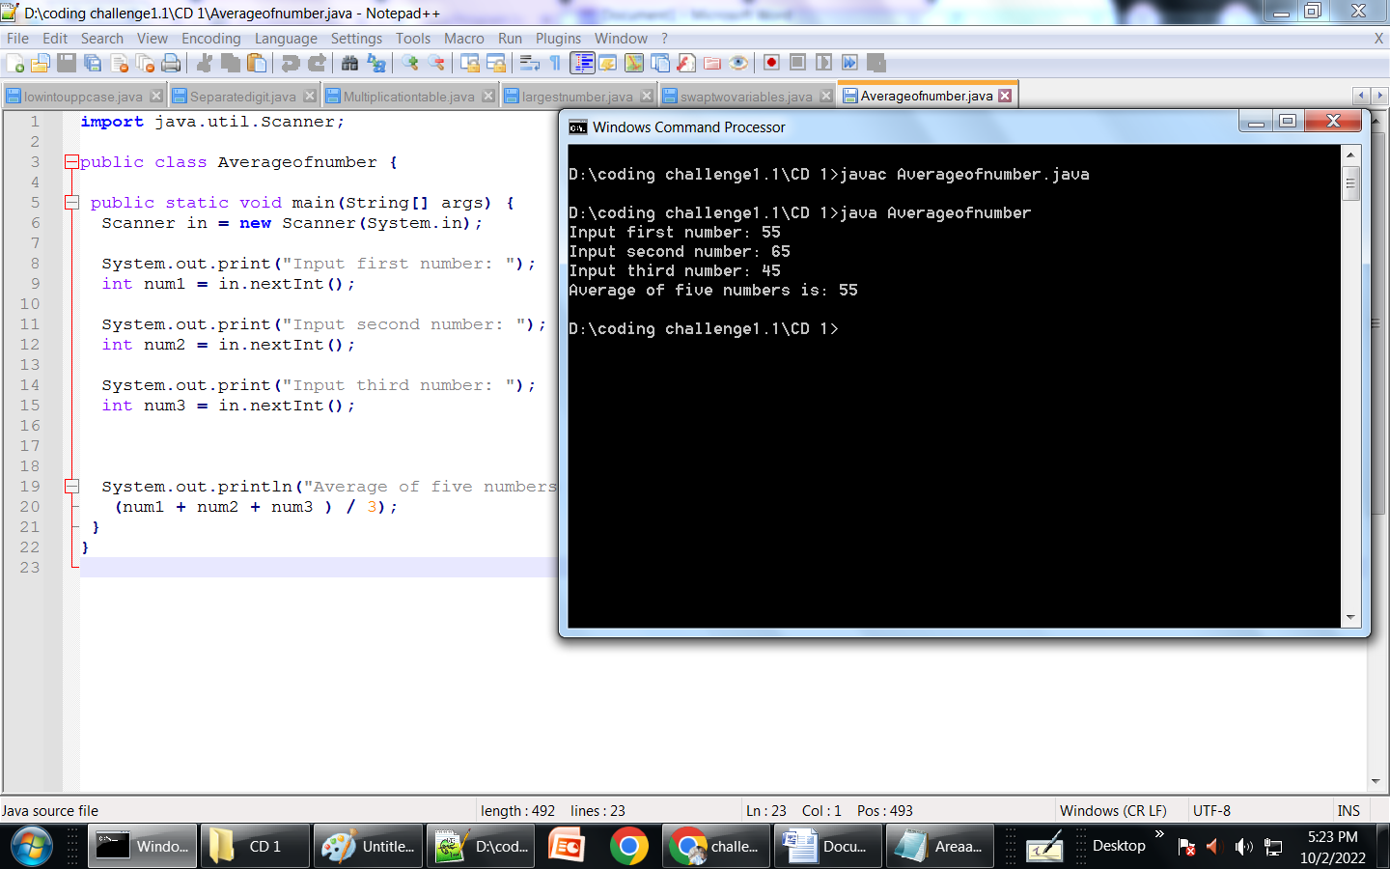

1. **Write a Java program to print the area and perimeter of a rectangle for the Width = 5.5 Height = 8.5**

**PROGRAM:**

*public class Areaandperimeterofret{*

*private static final double width = 5.5;*

*private static final double Height =8.5;*

*public static void main(String[] args) {*

*double Area = width*Height;*

*double Perimeter = (2*(width*Height));*

*System.out.println("Perimeter is = " + Perimeter);*

*System.out.println("Area is = " + Area);*

*}*

*}*

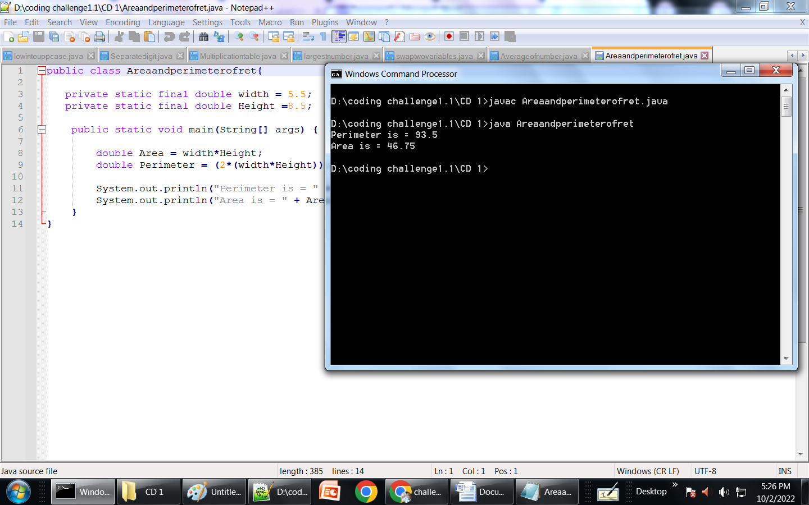

**6. Write a Java program to convert a decimal number to binary number.**

**Input Decimal Number: 6**

**Output: Binary number is: 110**

**PROGRAM:**

public class Decimaltobinary{

public static void main( String args[] ) {

int decimal = 6;

String binary = Integer.toBinaryString(decimal);

System.out.println("the binary number is :" +binary);

}

}

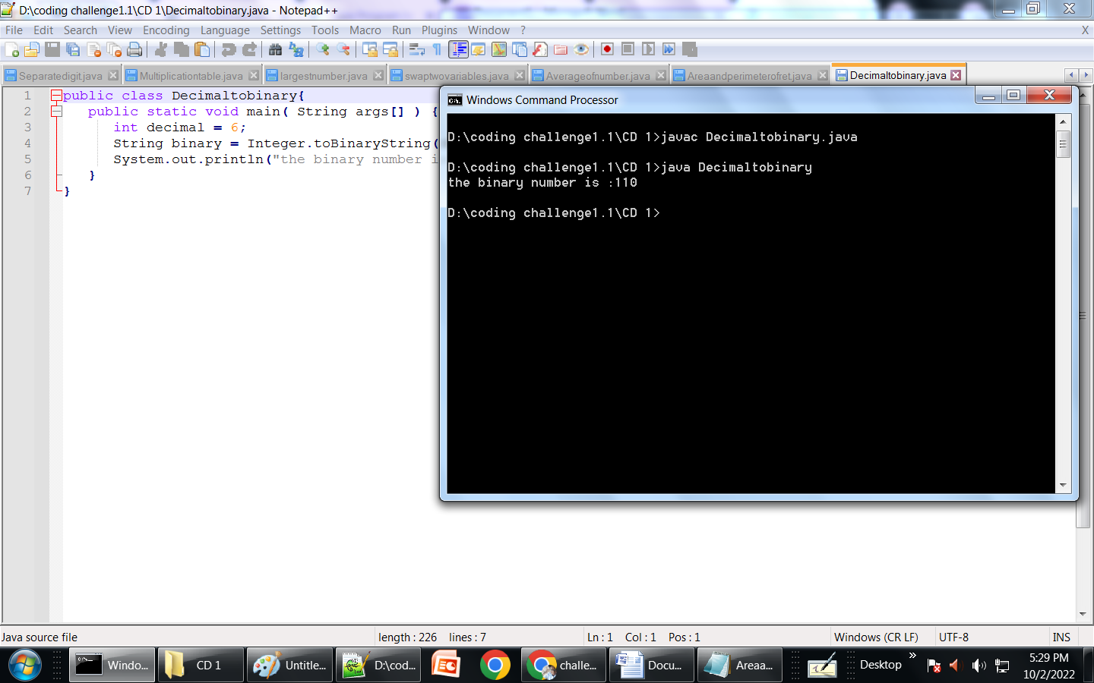

**7. Write a Java program to print the following grid.**

**PROGRAM:**

class Grid{

public static void main(String[] args) {

int [][]a = new int[5][8];

for(int i = 0; i < 5; i++)

{

for(int j = 0; j < 8; j++)

{

System.out.printf("a", a[i][j]);

}

System.out.println();

}

}

}

**OUTPUT:**

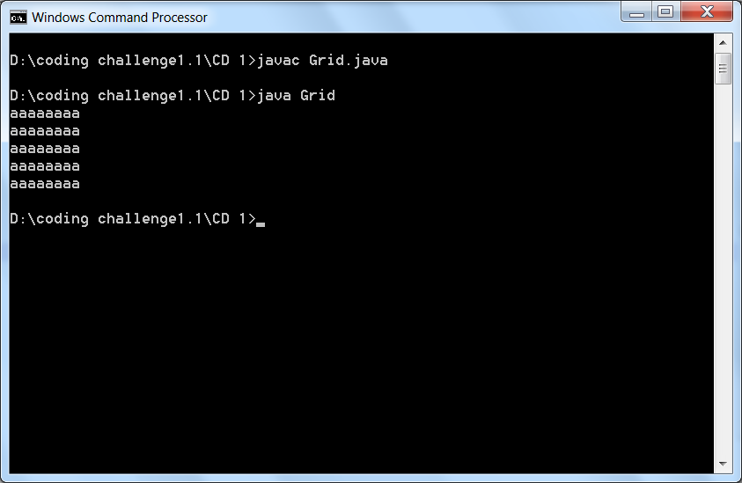

**8. Write a java program to remove a specific number: 23 from the following array: arr[11,22,33,34,43,32, 23]**

**PROGRAM:**

public class remove number

{

public static void main (String [] args)

{

int [] arr = {11,22,33,34,43,32,23};

int remove = 23;

int count = 0;

for(int i=0;i<arr.length;i++)

{

if(remove == arr[i])

{

for(int j=i;j<arr.length-1;j++)

{

arr[j] = arr[j+1];

}

count = count +1;

break;

}

}

if(count == 0)

{

System.out.println("Your number is not found....");

}

else

{

System.out.println("Element SpecificNumber has been removed successfully...");

for(int i=0;i<arr.length-1;i++)

{

System.out.println(arr[i]+"");

}

}

}

}

**OUTPUT:**

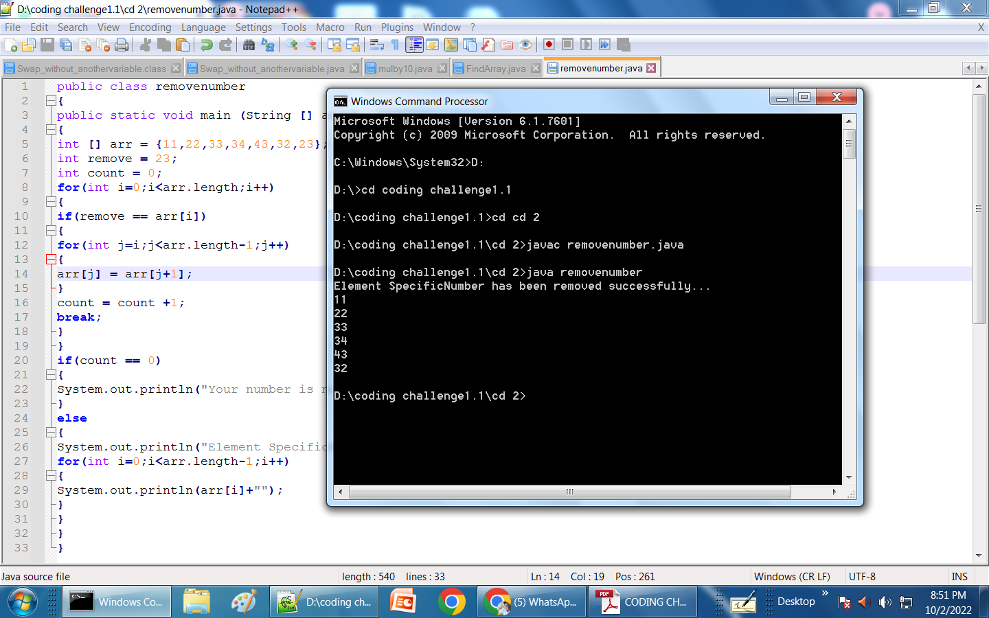

**9.Write a java program to copy the array values to another array in reverse order as If arr1[1,2,3,4,5] the resultant array should be arr2[5,4,3,2,1]**

**PROGRAM:**

class reverceorder {

public static void main(String [] args)

{

int arr[]={1,2,3,4,5};

System.out.println("Orginal Array:-");

for(int i=0;i<arr.length;i++)

{

System.out.println(arr[i]+ "");

System.out.println();

}

System.out.println();

System.out.println("Original Array printed in reverse order:-");

for(int i=arr.length-1;i>=0;i--)

{

System.out.println(arr[i]+ "");

System.out.println();

}

}

}

OUTPUT:

